DRAFT
GRAND TIMBER LODGE OWNERS’ ASSOCIATION
2021 ANNUAL MEETING
October 23rd, 2021
The full meeting was recorded and can be viewed on Grand Central by following this link
https://vimeo.com/639296108

ATTENDANCE
Board Present: Marc Block, Gerrit Mahsman, Tom Endres, Nick Doran, Lew Phinney, Roger Lemmon

Advisory Committee Present: Chris Maciejewski, Mark Orton, James Hagerman, Dave George, Jeff Carlson, Renae Phillips

Absent: Jay Keany, Matt Charley, Amanda Doebler, Marla Jensen

Management Present: Kimberly Tramontana, Josh Stuhr, Eli Yoder, Mary Kay Perrotti, Joe Clark-Fulcher, Peggy Helfrich, Stephanie Harding, Joanni Linton

Guests: Ashley Findley with McMahan & Associates
Chris McGill with Interval International

Call to Order – Establish Quorum of 10% – Marc Block, GTLOA Board President
The President of the Grand Timber Lodge Owners Association, Marc Block, called the meeting to order at 1:00pm. Marc established that quorum was met.

Call for Changes to the Agenda – Marc Block, GTLOA Board President

Introductions – Josh Stuhr, GTL General Manager
Board of Directors and Advisory Committee
Affiliate Representatives
Management Company

Call for the Approval of 2020 Annual Meeting Minutes – Marc Block, GTLOA Board President – owner vote required

MOTION: To approve the 2020 Annual Meeting Minutes

MADE BY: David Finch
SECONDED BY: William Husson
DISCUSSION: None

IN FAVOR: 89%
OPPOSED: None
ABSTAIN: 11%

Audited Financial Statement Review for the Fiscal Year Ending December 31, 2020 – McMahan & Associates
Overall, in the opinion of McMahan and Associates, we are in good financial health.
General Manager Report – Josh Stuhr, GTL General Manager
A property update was shared by GTL General Manager, Josh Stuhr
Interval International Update – Chris McGill, Interval International
An Interval International Update was shared, including GTL statistics on where owners are exchanging into and where exchangers are coming from.
Questions & Comments from the Floor – Marc Block, GTLOA Board President
Questions and comments were answered in the meeting, please refer to the video recording for specific questions and answers.

Board of Directors and Advisory Committee Election Results – Peggy Helfrich, HOA Operations Manager
The GTLOA has two open Board positions. Additionally, there are four open Advisory Committee positions with a 2-year term.
The voting results are shown on the next page.

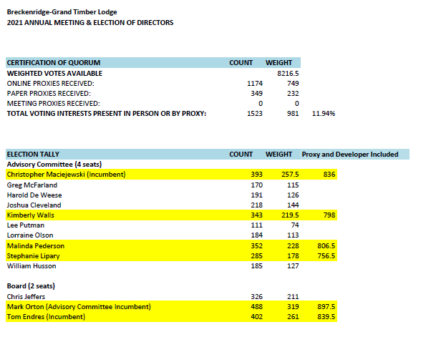

BOARD AND ADVISORY NEWLY ELECTED MEMEBERS - Peggy Helfrich
Board Members:
Tom Endres – reelected
Mark Orton - elected
Advisory Committee:
Chris Maciejewski – reelected
Kimberly Walls - elected
Melinda Peterson - elected
Stephanie Lipary - elected

Adjournment – Marc Block, GTLOA Board President

