DRAFT
GTLOA 4/27/22 Board and Advisory Committee Minutes

Attendance:
Board Members: Roger Lemmon, Lew Phinney, Marc Block, Mark Orton, Nick Doran, Jay Keany, Tom Endres
Advisory Committee Members: Matt Charley, Stephanie Lipary, David George, James Hagerman, Melinda Pederson, Renae Phillips, Kim Walls
Staff: Joe Clark-Fulcher, Mary Kay Perrotti, Nick Borovich, Peggy Helfrich, Eli Yoder, Joanni Linton

Call to Order – Marc - Time: 3:06PM

Changes to the Agenda

Approval of Minutes 10/23/21 Board Meeting Minutes
MOTION: To approve the 10/23/21 GTLOA Board meeting minutes.

MADE BY: Lew
SECONDED BY: Roger
Discussion:
IN FAVOR: all in favor
OPPOSED: none
ABSTAIN: none

Financials
GTLOA February 2022 Unaudited Financials
The GTLOA Operating budget shows a favorable variance of $279,227 YTD.
Operating Revenue shows an unfavorable variance of $27,921 YTD.
Operating Expenses show a favorable variance of $304,148 YTD.

The GTLOA Finance Committee reviewed the GTLOA February 2022 Unaudited Financials and made a recommendation to accept them at the 4/27/22 Board meeting.

MOTION: To accept the February 2022 Unaudited Financials.

MADE BY: Mark
SECONDED BY: Lew
Discussion:
- Mark- We are showing the operating expenses being favorable
IN FAVOR: all in favor
OPPOSED: none ABSTAIN: none

Financials
GTLOA FY2021 Audited Financials
GTLOA FY2021 Audited Financials Summary
Following the Finance Committee meeting on Tuesday, April 12th, it was determined that a $124K invoice was double paid in 2021.
  - This transpired due to a vendor billing error and change in personnel. It was not originally detected by BGV’s Accounts Payable software or the Financial Audit by McMahan due to separate invoice numbers being used.
  - Controls are being put in place to avoid this circumstance in the future, including a better-defined invoicing protocol for deposits and final payment.
  - The vendor has already given us a check for the duplicate payment, and it will post in 4/22.
These revisions reflect:
  - A $124K credit to the Unit Reserve P&L
  - A debit to Other Receivable
The GTLOA Finance Committee reviewed the GTLOA FY2021 Audited Financials prior to the audit adjustment and made a recommendation to approve at the April 27, 2022, Board meeting.
BOARD ACTION REQUIRED
MOTION: To approve the GTLOA FY2021 Audited Financials.
MADE BY: Mark
SECONDED BY: Roger
DISCUSSION:
- Marc- There was an invoice that was paid an extra time so we ended up overpaying an invoice by six figures. The good news is we have already received a full refund.
IN FAVOR: all in favor
OPPOSED: none
ABSTAIN: none
Financials
Accounts Receivable Update
Discussion:
- Joe- As of 4/15/22 we are at 87% of dues paid which is a little ahead of where we were at last year. We expect to end up around 97% paid by year end. We feel great about where we are.
- Marc- I read recently about another property (not BGV) that is assessing a $1400 per owner special assessment to cover bad debt. We are very fortunate for the hard work of BGV to help us avoid this.
Financials
GTLOA Reserves Review Update
Mark Orton shared a summary from the 2/21/22 Reserves Review meeting. Highlights included:
- Mark- This was a very productive exercise. We did a deep dive into the process with BGV along with reviewing the third-party audit from OAC. They had some recommendations including potentially delaying some projects until the supply chain calms down a bit.
- Nick- Thank you Mark. The only big change from OAC’s process is that they look at a 25-year study and we look out 30 years. We did take a number of recommendations from OAC into account when building our budget.
- Mark- This process was very informative for me. It was very reassuring to see what BGV is doing.
Financials
GTL Reserve Studies Update
Reserve Study Review
April 2022
2021 Projects
The execution of projects in 2021 was encouraging following several deferments in 2020. The quality and implementation of window & balcony door replacements in building 5A was a continued success, with efficiencies being created by the vendor to open unit inventory earlier than anticipated. Buildings 5 & 6 also received new carpet and paint, ensuring that residences and common areas remain looking fresh and up to date.

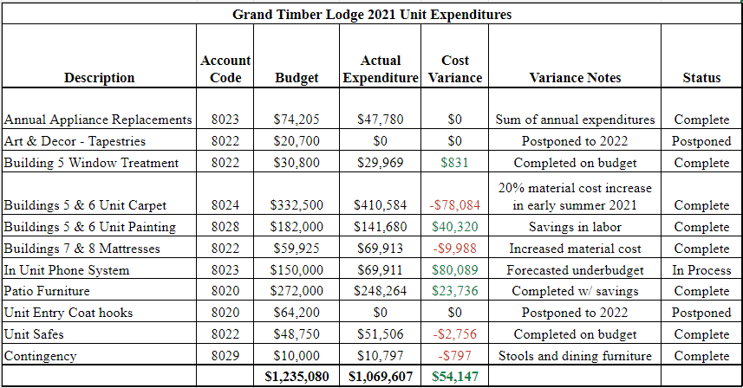
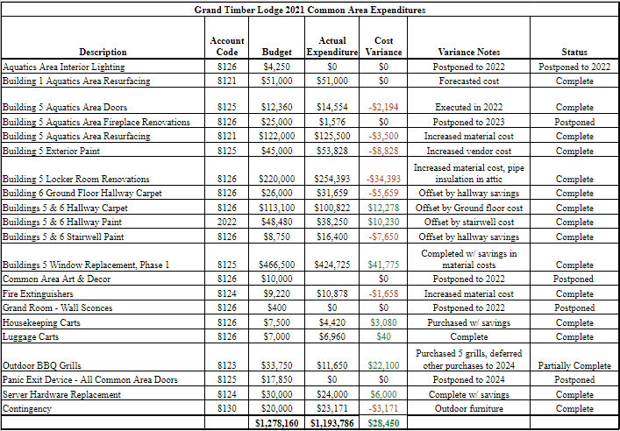

2022 Projects
Most notable of the 2022 projects includes the upgrade of soft furnishes in the living rooms throughout the property. These designs have been carefully considered and curated with quality, cost and timing all being top priority. A new splash pad in the Building 5 aquatics as well as cardio equipment in the Fitness Center are great highlights that will keep the amenities a hit for all owners and guests.
The unit remodel is being delayed ensuring that design and execution are being delivered with the highest attention. The following two years will set the tone for the full scope of work that will kick off in 2025, where unit blocking, vendor considerations, and Gant charts are already in the works.
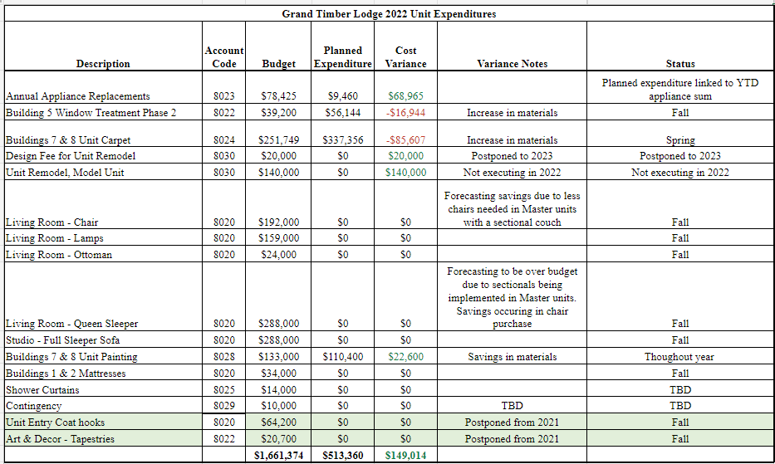

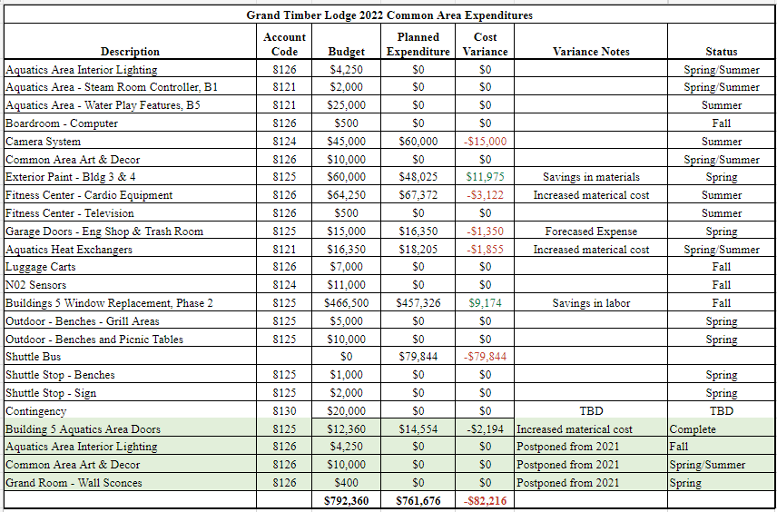

Updates Made in Review Process
There are several changes being made to the reserve study to ensure that long term cashflow is being reflected accurately. The review of capital expenditures this season has identified a redundancy in ADA unit remodels, which can be encapsulated during the 15-year unit remodel scope of work and have been removed from the budget altogether. Shuttle replacements have been added to the capital budget, which has resulted in savings to the operating budget due to interest not being accrued on a lease throughout the course of a year.
Several efficiencies were created by classifying items such as ellipticals and treadmills into a category titled Cardio Equipment, thus providing more versatility for future replacements. In addition, the quantity of furniture replacements was slightly increased to ensure that backstock was maintained and damages are being repaired or replaced in a timely manner.

Design Updates
Living room furniture has been widely discussed as we strive to maintain the Arts and Crafts design concept at Grand Timber Lodge. Several samples have been provided, curtesy of the vendor, to guarantee the correct selection is made. Some considerations during this process have included the ability to add a mattress protector to the sleeper sofa, the style of furniture to potentially eliminate the need for an ottoman, and the durability of the furniture itself.
Discussion:
- Marc- Nick could you please talk about the warranty and work we are doing with the hot tubs?
- Nick- We did, unfortunately, have some of the finish peel from the work that was done in the fall. Luckily it is covered under the 10-year warranty. We also do not expect it to have much of a guest impact.
Financials
Annual Accommodation Unit Regulatory Fee

On November 23rd, 2021, the Breckenridge Town Council passed a new ordinance No. 35 amending Chapter 1, Title 4 of the Breckenridge Town Code concerning the annual accommodation unit regulatory fee. This was after the Board approved the FY2022 budget. The 2022 regulatory fee is $400 per studio/bedroom, in addition to the current business and occupational license tax (BOLT.) All dollars generated by this regulatory fee will be used to support the Town’s workforce housing policies and programs, including buy downs, lease to locals, acquisition of deed restricted units, and/or construction of new units. More info on how these funds will be used were featured in a recent Summit Daily News article, which can be found here: https://www.summitdaily.com/news/breckenridge-commits-50-million-to-ambitious-workforce-housing-plan/

In order to meet the payment deadline of 1/27/22 and avoid risk of losing the existing short term rental licenses, Peak Resort Management (BGV) paid this fee on behalf of GTLOA. Therefore, GTLOA will incur this unbudgeted expense in FY2022, and the ratification of this expense is noted below, requiring Board approval.

As always, staff will do what we can to help drive a favorable outcome by the end of the fiscal year. In addition, GTLOA also has some retained earnings, and the 2022 insurance premiums did not increase as substantially as they could have.

Lastly, since this ordinance passed, BGV has been engaged in discussions with the Town of Breckenridge regarding the specifics of this fee and the substantial financial impacts to all BGV owners. These discussions are still ongoing, and we will keep the Board apprised of any new developments.

The GTLOA Finance Committee reviewed this motion and made a recommendation to approve this ratification at the 4/27/22 Board meeting.

Motion: To ratify the payment of the Annual Accommodation Unit Regulatory Fee paid by Peak Resorts Management on the behalf of GTLOA in the amount of $138,000.

Made by: Tom
seconded by: Mark
Discussion:
- Mark- It is great that BGV stepped up to pay this. It was not an option for us to not pay it as it would have prevented our owners from being able to rent their units
- Nick- Thank you all. We are hoping there will be some changes to this as they fine-tune it. There was a one-size-fits-all approach to this, but it is not a one-size-fits-all issue.
- Kimberly- There have been quite a few other members of the local community that have voiced similar concerns to BGV’s with this. We are also working with the ARDA Resort Owners Coalition on this.
- Marc- BGV has been very proactive here with trying to take care of their employees’ housing needs and the town is double dipping with also putting this tax on them. Thank you to Kimberly and Nick for all the work you have done to make sure our employees’ needs are met.
In favor: All in favor
Opposed: None
ABSTAIN: None

General Manager Report
Grand Timber Lodge General Manager Report
April 2022

Grand Timber Lodge has welcomed many familiar faces to our leadership team this year. These individuals were carefully selected based on their proven passion for the owner and guest experience, as well as their ability to innovate and elevate. Please join us in congratulating the following BGV employees on their internal promotions:

Rob Wilson – Grand Timber Lodge Engineering Manager
- Rob’s tenure with BGV dates back to 2015. He has served as an Owner Relations Specialist, Gold Point Engineering Manager, and Grand Lodge on Peak 7 Assistant Engineering Manager. Rob’s passion for team development is already reflecting impressive results within the GTL Engineering Department.
Derek Schade - Grand Timber Lodge Assistant Engineering Manager
- Derek has spent two years with the GTL Engineering Team as a technician before his recent leadership promotion. He provides years of experience in the trades and strong problem-solving skills. Derek’s organizational skillset and can-do attitude are also of great benefit to GTL.
Jessica Perez – Grand Timber Lodge Assistant Housekeeping Manager
- Jessica has been a member of the GTL Housekeeping Team since 2014. She has served in several roles that offer a unique perspective on cleanliness and quality. Jessica’s leadership presence in the largest department on property has been warmly welcomed.
Brooke Balderston – Grand Timber Lodge Assistant Guest Services Manager
- Brooke’s positive influence on the GTL Front Desk dates back to 2017. Her thirst for knowledge really shined through during her time cross training with Owner Relations and also volunteering for additional assignments. Her helpful, supportive approach to leadership resonates with the entire GTL Guest Services Team.

Elevating current amenities while introducing new and innovative experiences remains a top priority as we happily welcome owners and guests to GTL.

2022 Room Upgrades

- Buildings 7 and 8 are being refreshed with new carpet and paint, rounding out a four-year cycle of these room upgrades.
- Soft furnishings are being replaced property wide, creating the welcoming atmosphere owners have grown to love in their home away from home.
- Phase 2 of the Building 5 window and balcony door replacements will be completed to round out this Building 5 upgrade.

2022 Resort Upgrades

- Buildings 3 & 4 will be updated with fresh exterior paint.
- An aquatics play feature will be added to the Building 5 Splash Pad to create more outdoor fun for little ones on vacation.
- The Building 6 Locker Room will be upgraded, completing all locker room renovations throughout the resort.

Looking Ahead

- Wifi will be upgraded throughout the resort. This technology advancement will make way for further improvements such as streaming and casting capabilities in rooms.
- Window and balcony door replacements will continue in Building 6.
- The fireplace in the Building 5 Aquatics Center will be upgraded.
- Dining room furniture and barstools will be upgraded throughout all rooms.
Discussion:
- Roger- I just want to say that there are a lot of issues with waterless urinals if they are not well maintained but BGV is doing exactly what they need to do to keep them in tip-top shape.

Updates and New Business
Winter 2023 BiGVARS update
We are pleased to share that the Winter 2023 reservation request system has been successfully completed.

Approximately 2,192 owners representing 2,359 contracts placed requests to make reservations for the Winter 2023 season. Participation in the reservation process was up slightly year over year.

Overall, the numbers appear to closely follow last year, with some positive increases in top preferences, showing the steady state the process has achieved. Specifically, here are the results:

- 54.13% were assigned their top choice (up from 52.17% in 2022)
- 69.31% were assigned a top 3 preference (65.73% in 2022)
- 78.72% were assigned a top 6 preference (76.66% in 2022)
- 88.81% were assigned a top 15 preference (87.41% in 2022)
- 1.82% were assigned a choice outside of their top 15 (1.40% in 2022)
- 9.37% did not receive any of their choices and were auto assigned (11.18% in 2022)

Of the 2,359 contracts represented in the assignment process, 221 were automatically assigned a week, meaning one of their requested weeks was not assigned. These results are down over 2022 by 1.81%. As you may recall, priority during the next reservation round is increased for those who did not receive one of their top choices. This maintains our efforts to fairly distribute top choice preferences amongst all Winter owners over time.

Breckenridge Grand Vacations does understand that not all owners favor this reservation request and assignment process, and we are committed to listening closely and carefully to the feedback we receive from our owners. If at any time it is determined that most owners are not satisfied with using the GTL Annual Reservations System, and/or if an even better system is identified, we will gladly collaborate with the GTLOA Board and Advisory Committee to ensure the best possible experience for our owners.

Updates and New Business
Proposed Updates to the Rules and Regulations
After a review of the Rules and Regulations, please find the following proposed updates.

9. Normal made housekeeping services is provided for each Vacation Unit prior to check-in. This service, the cost of
which is covered by the Vacation Unit Assessment, is the responsibility of the Managing Agent and his staff. Other housekeeping services are available to occupants for a fee. A complimentary towel exchange is available half way through the Vacation week. A pool towel for each guest will be left in the unit and will be exchanged half way through Vacation week.

Made by: Tom
seconded by: Roger
Discussion:
- Mark- I would like to change the wording to remove the word made and add housekeeping services
- Tom- I accept the change to the motion
- Roger- I second it again
In favor: all in favor
Opposed: None
ABSTAIN: None

13. Rules governing the use of the swimming pool are posted. Children 14 years of age or under shall not be permitted in the pool area unless accompanied by an adult. The pools, hot tubs, and club will close at 10:00 p.m., except for the Building 5 hot tubs aquatics, which will remain open until 11:00 p.m. Regardless of closing times, quiet hours should be observed from 10:00 p.m. to 8:00 a.m., per Section F, Paragraph 7 of these Rules and Regulations. Pool hours and rules are subject to change at the discretion of the Managing Agent. All Owners and guests must have a room key with them while using the swimming pool and hot tubs or have checked-in with the front desk if using day privileges. The Association does not provide a lifeguard for the swimming pools. All users of the swimming pools and hot tubs shall swim or otherwise use it at their own risk. The Association is not responsible for any injuries to any person which may occur while using the swimming pools or hot tubs. Diving or jumping into the swimming pools and hot tubs is strictly prohibited.

Motion: To update the Rules and Regulations as noted above.

Made by: Marc
seconded by: Tom
Discussion:
- Marc- it has been a couple of years now since we made the change for the hot tubs. As long as we have not seen any issues with noise, I am all in favor of it.
- Nick- We have not seen very many noise complaints because of this.
In favor: all in favor
Opposed: None
ABSTAIN: None

Miscellaneous
Comments to/from Staff
Discussion:
- Nick- Marc I know you had a couple questions that we were going to look into.
  - We looked into the wallet on grand central that can store credit cards and confirmed that it is the same secure pay software that we currently use for reservations in TimeShareWare.
  - The digital owner cards will only be available to the actual owners on the deed of the property. Other relatives will have to get a physical card in order to use the property.
- Marc- I did confirm with Rick Tramontana that all GTL owners regardless of where they purchased from will have access to club benefits at GTL.

Snapshot
GTL Snapshot for April 2022 Board Meeting
- Remained consistently rated high on Trip Advisor, currently at #5 of 32 properties under “Hotel” category and have 4.5 out of 5 stars! Please find specific feedback here
- Continued excellence in owner and guest service scores YOY:
GTL Service Score Comparison | Last Year’s Avg  4/1/20-3/31/21 | This Year’s Avg  4/1/21-3/31/22
Front Desk | 9.03 | 9.10
Room Engineering | 8.65 | 8.70
Housekeeping, Room Cleanliness | 9.21 | 9.27
Housekeeping, Staff | 9.01 | 9.12
Activities | 9.01 | 9.14
RMS | 9.02 | 9.18
The Boot | 8.45 | 8.45
Shuttle | 9.47 | 9.52
Overall accommodations | 8.83 | 8.94
GNPS | 63.06% | 67.51%
GONPS | 66.06% | 70.14%

- Reserve studies % funded based on projected fund balances as of 1/1/22 for 30-year forecast:
  - Unit – 2.87%
  - Common – 3.38%
- 2022 Increase to the Dues Breakdown (6.7% increase YOY):
  - Operating Fund – 5.35% of total increase
  - Unit Reserve – 0.71% of total increase
  - Common Reserve – 0.61% of total increase
    - Total Reserve – 1.32%

- HOA dues comparison for 2022:
Valdoro Mountain Lodge Breckenridge 2 Bedroom $2,900 (2021)
The Ranahan by Welk Breckenridge 2 Bedroom $2,540 (540,000 points)
Grand Colorado on Peak 8 (Colorado) Breckenridge 2 Bedroom $2,345 (2022)
Grand Colorado on Peak 8 (Breckenridge) Breckenridge 2 Bedroom $2,039 (2022)
Grand Lodge on Peak 7 Breckenridge 2 Bedroom $1,874 (2022)
Marriott Mountain Valley Lodge Breckenridge 1 Bedroom $1,800 (2021)
Grand Timber Lodge Breckenridge 2 Bedroom $1,460 (2022)

- GTL Annual Dues Increases:
Grand Timber Lodge Owners Assoc.
Annual HOA Dues Analysis
 | 2 Bedroom
 | Annual | Annual | Annual
Year | Dues | $ Incr  (Decr) | % Incr  (Decr)
2022  2021 | $1,459.82  $1,368.65 | $91.17  $115.81 | 6.7%  9.2%
2020 | $1,252.84 | $75.51 | 6.4%
2019 | $1,177.33 | $84.77 | 7.8%
2018 | $1,092.56 | $80.24 | 7.9%
2017 | $1,012.32 | $64.45 | 6.8%
2016 | $947.87 | $27.47 | 3.0%
2015 | $920.40 | $60.96 | 7.1%
2014 | $859.44 | $62.88 | 7.9%
2013 | $796.56

- Annualized increase to dues:
  - 2003 – 2022 GTL annualized dues increase – 5.3%

- Budget to Actual variance comparison (exclusive of retained earnings):
  - 2017 Budget $9,196,125
- 2017 End of Year Op Fund Deficit $10,486 – 0.1% of the total budget
  - 2018 Budget $9,924,226
- 2018 End of Year Op Fund Deficit $13,525 – 0.1% of the total budget
  - 2019 Budget $10,630,499
    - 2019 End of Year Op Fund Excess $526,987– 5.0% of the total budget
  - 2020 Budget $11,399,247
    - 2020 End of Year Op Fund Excess $287,881 – 2.5% of the total budget
  - 2021 Budget $12,348,997
    - 2021 End of Year Op Fund Deficit ($291,501) – 2.4% of the total budget
  - 2022 Budget $13,169,854
  - Five-year average budget to actual variance is just 2.0%

Important Dates
GTLOA Finance Committee GoToMeeting:
#1 - Wednesday, October 5, 2022 - 3-5pm
#2 if needed - Thursday, October 6, 2022 - 3-5pm

GTLOA Board and Annual Meetings:
Saturday, October 15, 2022 (please note the date change from 10/22/22):
- In person with remote option
- Property Tour – start time and location TBD
- Board Meeting – 9-11am (in-person and GoToMeeting participation options available)
- Lunch – 11:30am-12:30pm (for all in-person Board Meeting attendees)
- Annual Meeting – 1pm via GoToWebinar for all (no in-person participation)

Contract / Agreement Dates:
- Management Agreement:
  - Initial term from 1/1/2021 – 12/31/2030
  - Auto-renews for successive periods of 5 years
  - Action for change required 180 days prior to auto-renewal

- Interval International:
  - Expires 12/31/2024
  - No auto-renewal

- Resale Agreement:
  - New agreement went into effect 1/1/2019 and auto-renews annually
  - Action required with written notice 90 days prior to auto-renewal

- External Reserve Studies Review:
  - Every 5 years
  - Next due in 2026

- The Boot Saloon Restaurant Lease
  - Expires April 30, 2029
  - Option to renew the lease for two additional 5-year terms
  - Notice to exercise renewal must be given between 365 and 180 days before the end of the lease

Review Action Item List
#185 – Explore the feasibility of adding new water features for all ages. A custom design is being curated to fit the footprint of the splashpad and ensure safety in this high traffic area, with a goal of having the feature installed mid-summer. In process.

#186 – Research commercial rooftop fire suppression system that will use the pool water to mitigate if a fire arises. Research shows that our winter alpine environment does not allow for this option. Closed at the 4/27/22 Board meeting.

#187 – Deliver an updated Memorandum of Understanding when fully executed – This was sent on 11/2/21. Closed at the 4/27/22 Board meeting.

#188 – Send Joanni Linton, Director of Resort Operations’, contact information to the GTLOA Board and Advisory Committee. This information was sent on 10/25/21. Closed at the 4/27/22 Board meeting.

#189 – Send the Board and Advisory Committee the TSW update timeline prior to all owner communication. This information was sent on 11/29/21. Closed at the 4/27/22 Board meeting.

#190 – Inform the Board and Advisory Committee the GM announcement. This information was sent on 10/27/21. Closed at the 4/27/22 Board meeting.

#191 – BGV to add in the next owner newsletter that owners have the ability to use deeply discounted owner rates at the Breck Inn when available. This has been added to the November 2021 newsletter. Closed at the 4/27/21 Board meeting.

Review New Action Items from the 4/27/22 Board Meeting:
- No new Action Items

Adjournment By: Roger Time: 4:16

